**SOP – Virtual Private Network**

**Implementation Guide**

# VPN Gateway

Azure VPN Gateway is a service that can be used to send encrypted traffic between an Azure virtual network and on-premises locations over the public Internet. Multiple connections can be created to the same VPN gateway. When you create multiple connections, all VPN tunnels share the available gateway bandwidth.

**Point to Point connection**: IPsec/IKE VPN tunnel connection between the VPN gateway and an on-premises VPN device.

**Site to Site connection**: VPN over OpenVPN, IKEv2, or SSTP. virtual network from a remote location like a conference or from home.

## Prerequisites to deploy VPN Gateway

1. Require a Microsoft Entra Tenant.
2. Following fields should be noted.
   1. Organization name.
   2. Initial domain name.
3. You require at-least the following roles to deploy a VPN Gateway.
   1. Network Contributor.
   2. Subscription Contributor.
   3. Security Administration.
4. A subnet with a name **GatewaySubnet**.

## Azure VPN Application

Copy paste the URL to access the application with admin consent of the organization. On the permission request page, select accept.

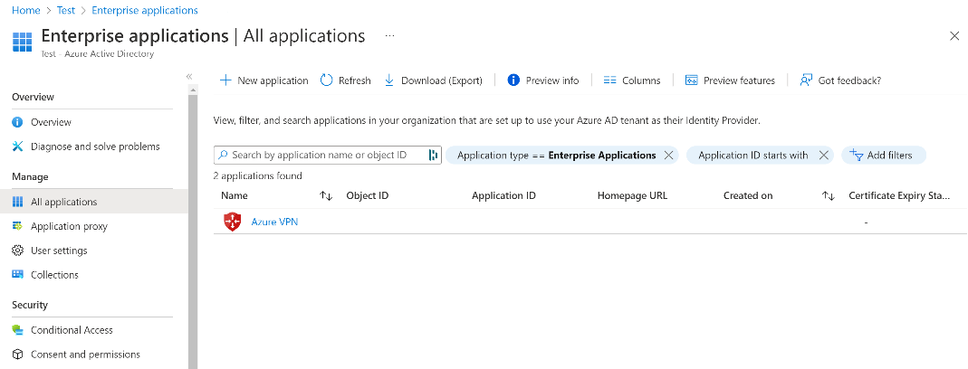

## VPN Gateway topology and design

### Point to Point VPN

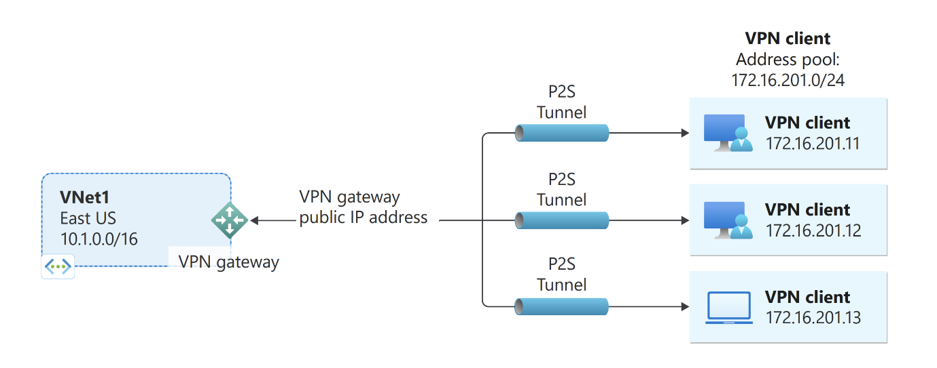

### Site to Site VPN

